

**CMPS350 Group Project**

**Phase 2 Report**

**Group Name: ArtiCat**

**GitHub Link:** <https://github.com/maria-ma2108455/CMPS350--Project>

QUID: 202009566 Student Name: Aisha Abdul Quadir

QUID: 202103676 Student Name: Mais Abushahla

QUID: 202108455 Student Name: Maria Attili

Dr. Mucahid Kutlu

Date: May 11, 2024

Section: L51

Spring 2024

# Grading Rubric

|  |  |  |  |  |
| --- | --- | --- | --- | --- |
| Criteria | % | Functionality* | Quality of the implementation | Grade |
| Design and implement the Data Model. | 10 | 100% Working |  |  |
| Init DB: populate the database with the data from the json files in seed.js | 5 | 100% Working |  |  |
| APIs and Repository Implementation to read/write data from  the database | 25 | 100% Working |  |  |
| Statistics use-case with NextJS | 40 | 100% Working |  |  |
| Documentation  - Data Model diagram.  - UI Design with screenshots and description.  - Database queries.  - Conducted tests and evidence.  - Contribution of each team member [-10pts if not done] | 20 | 100% Working |  |  |
| Total | 100 |  |  | 100 |
| Bonus - successful deployment of the app and the Database to a cloud hosting service such as <https://vercel.com/> | 5 | 90% Working |  |  |
| Copying and/or plagiarism or not being able to explain or answer questions about the implementation | -100 |  |  |  |

# Contribution of each team member

|  |  |
| --- | --- |
| Name | Percentage of Contribution |
| Aisha Abdul Quadir | 33.3% |
| Mais Abushahla | 33.3% |
| Maria Attili | 33.3% |

More detailed information about each of our tasks will be given in the self-reports.

# Data Model Diagram

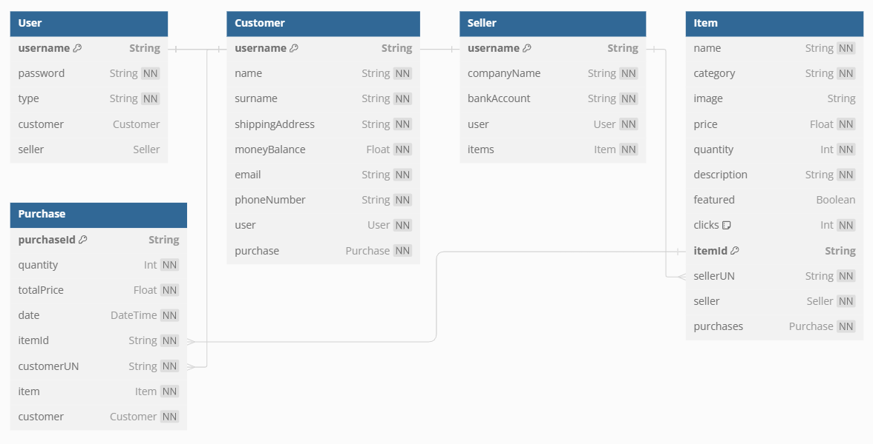

# List Of Statistics

1. Total number of customers, companies, categories and products
2. Top 3 most bought products over the last 6 months
3. Total number of customers per country.
4. Monthly revenue of Products by category
5. Top 5 most clicked products
6. Top 3 Contributing Companies

# Statistics Use Case UI Sketch

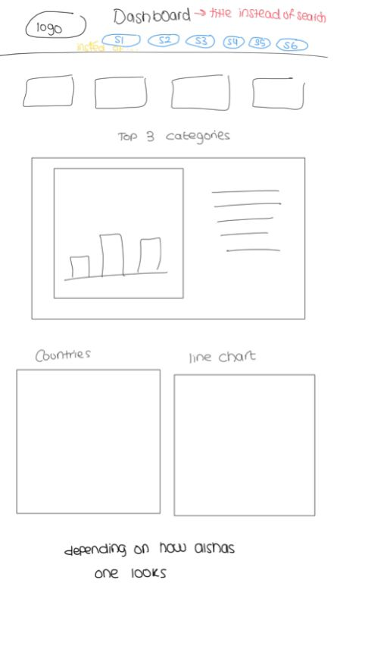

# UI Design with screenshots and description

For the user interface, we have represented the majority of statistics using charts, utilizing a library called [Recharts](https://recharts.org/en-US/) which can be installed using the following command: npm install recharts.

We have added an admin user that can only access the statistics page. Once the admin logs in, they are directed to the statistics page. No other user can access the statistics page.

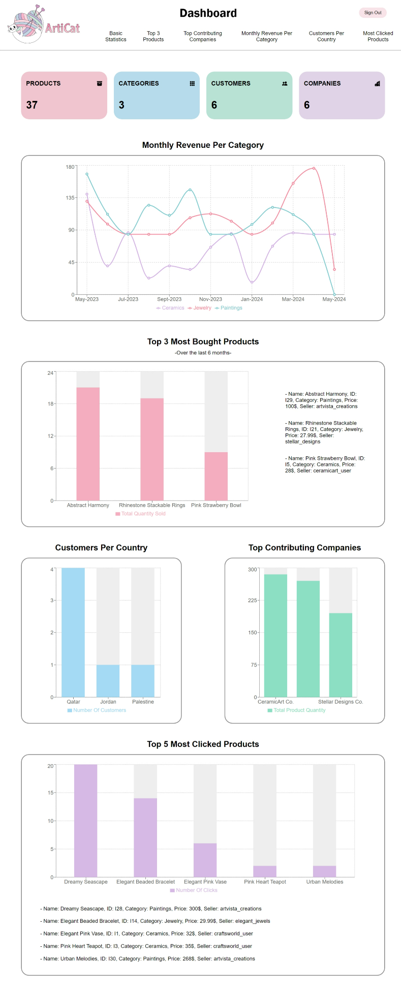

# Database queries

## Statistic 1

Total number of customers, companies, categories and products

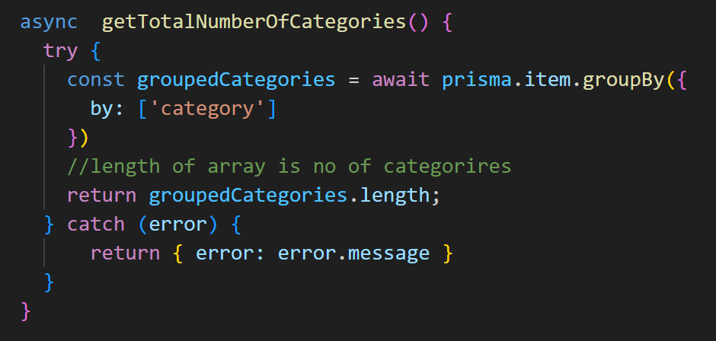

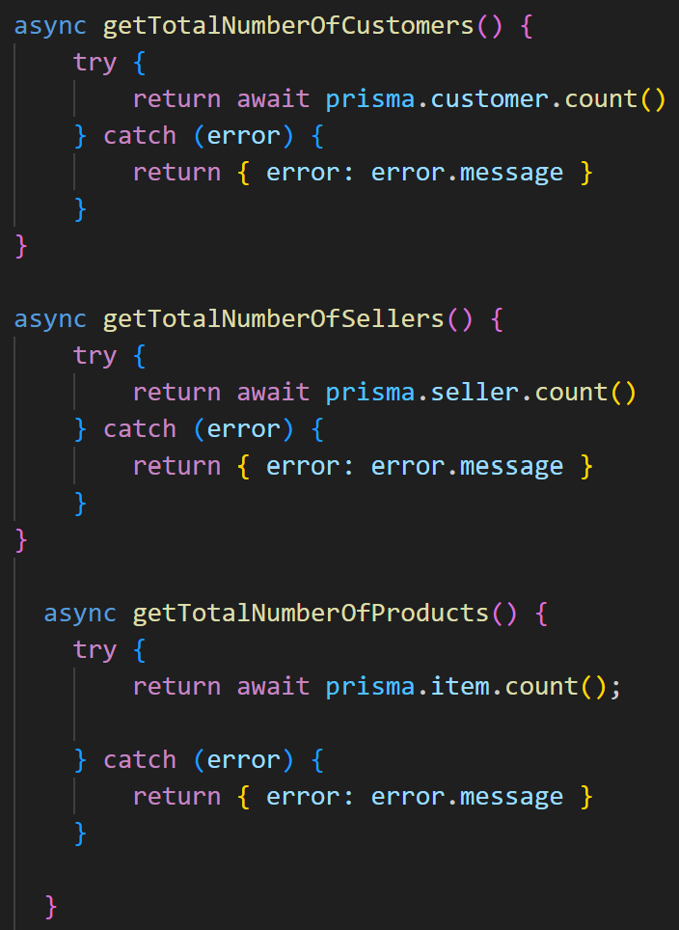

## Statistic 2

Top 3 most bought products over the last 6 months

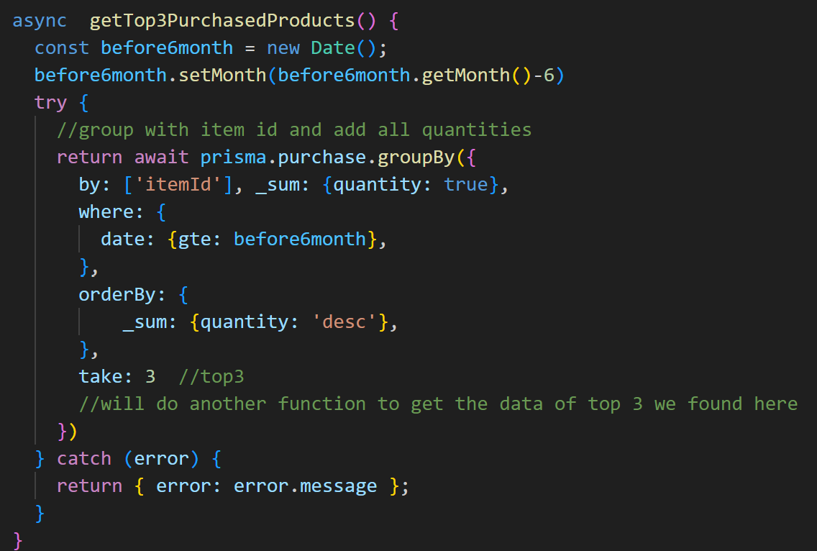 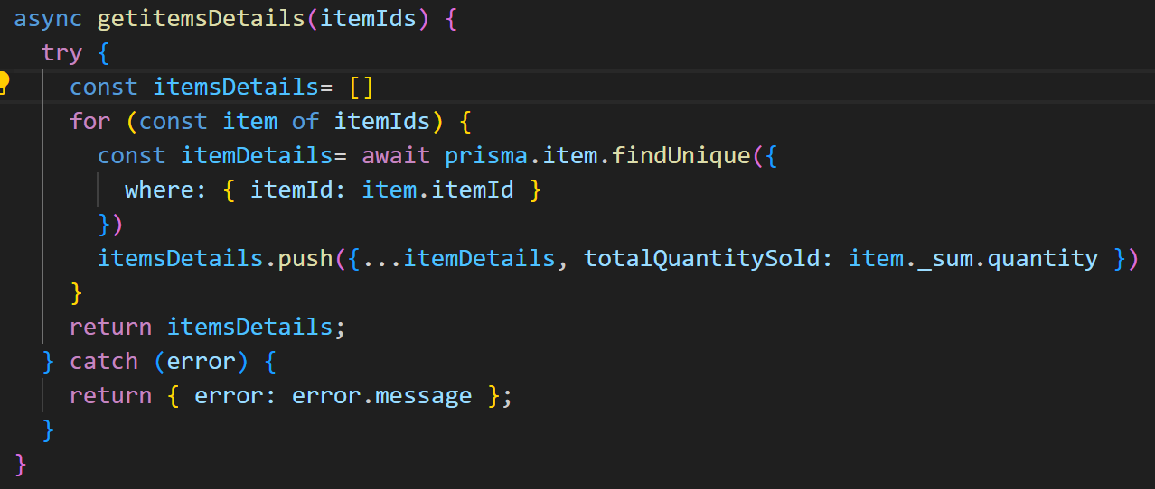

## Statistic 3

Total number of customer per country

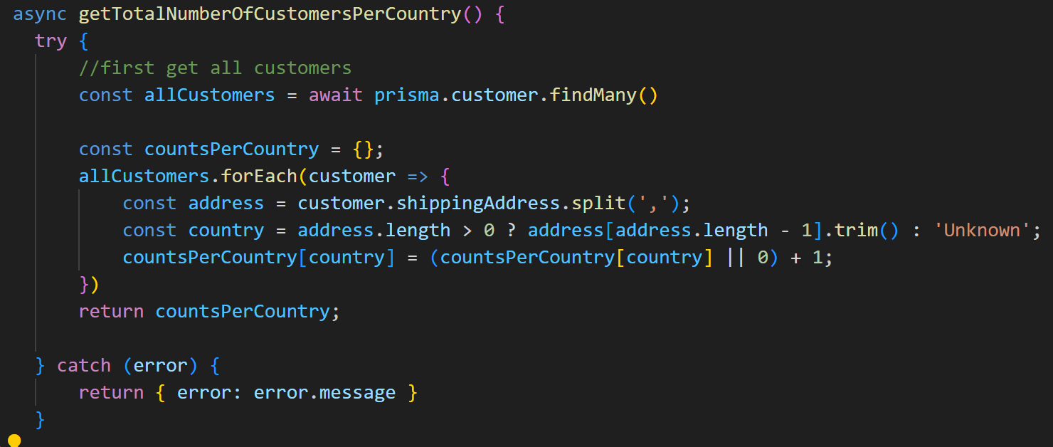

## Statistic 4

Monthly revenue of Products by category over the last year

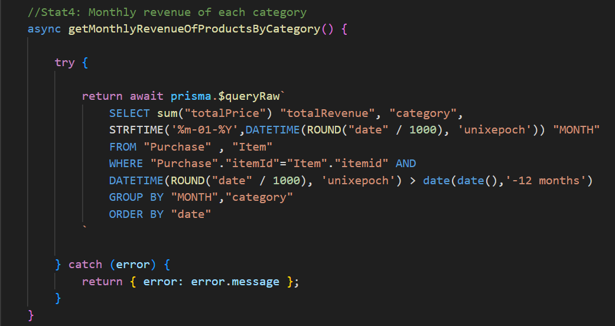

## Statistic 5

Get top 3 most clicked products

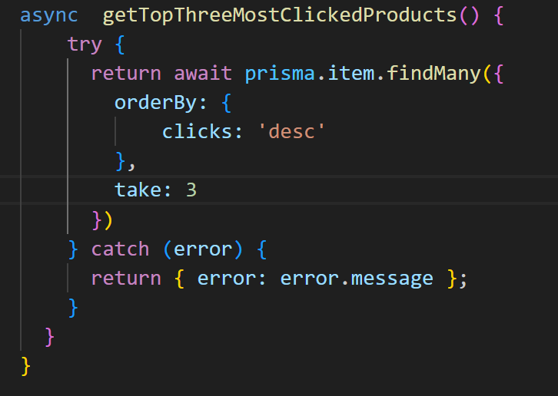

## Statistic 6

Top 3 Companies which contribute the most quantity of products

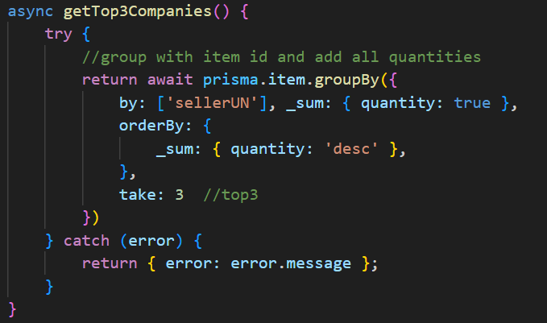

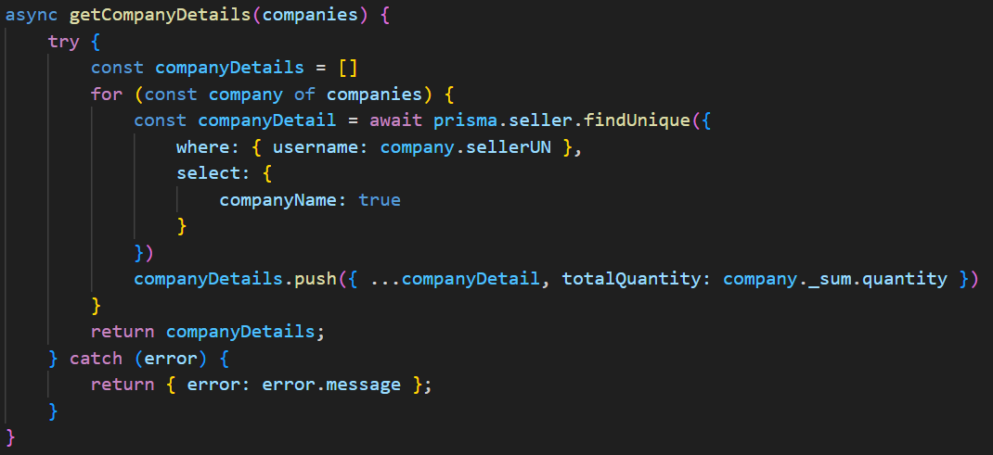

# API Routes

|  |  |  |
| --- | --- | --- |
| Verb | PATH | Functionality |
| GET | /api/items | Gets all items |
| GET | /api/items?category= | Gets items of specific category |
| GET | /api/items?searchValue= | Gets items that matches search value |
| GET | /api/items?featured= | Gets the featured items |
| POST | /api/items | Adds an item |
| GET | /api/items/:itemId | Gets a specific item |
| PUT | /api/items/:itemId | Updates a specific item |
| PUT | /api/items/:itemId/clicks | Updates the clicks of a specific item by 1 |
| GET | /api/:userId | Gets a specific user |
| PUT | /api/:userId | Updates a specific customer user |
| GET | /api/:userId/items | Gets all sale items of a seller |
| GET | /api/:userId/items?category= | Gets available/sold-out items of a seller |
| GET | /api/:userId/history | Gets sale/purchase history of a user |
| POST | /api/purchases | Adds a purchase for a customer user |

# Conducted tests and evidence

## Usecase 1: Login

### Wrong password or username:

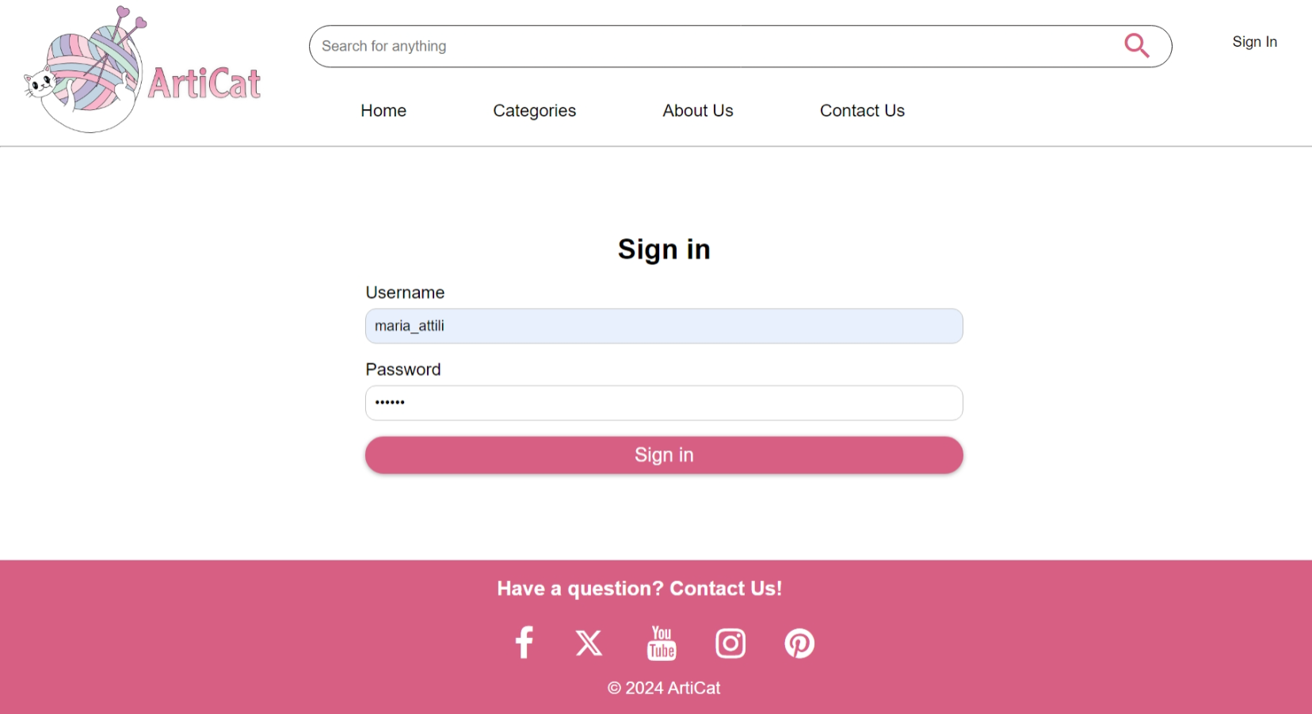

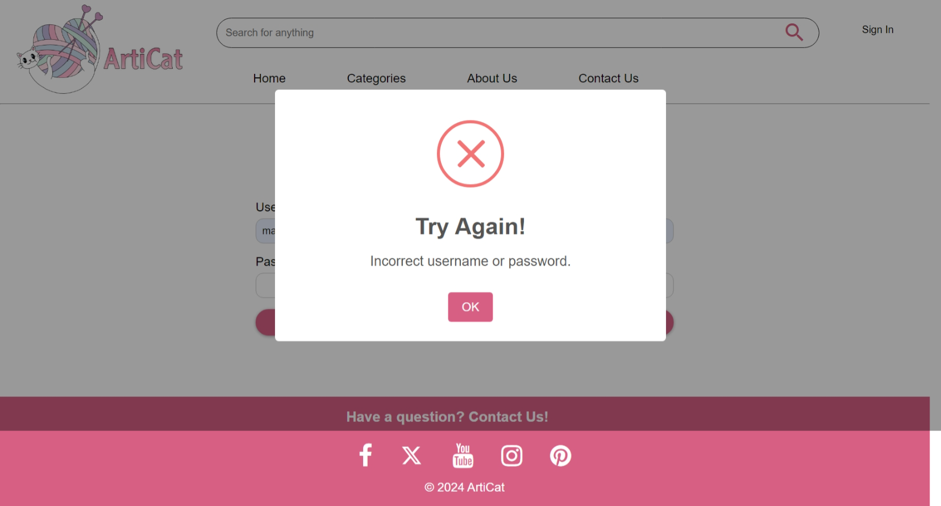

### Customer successfully logs in:



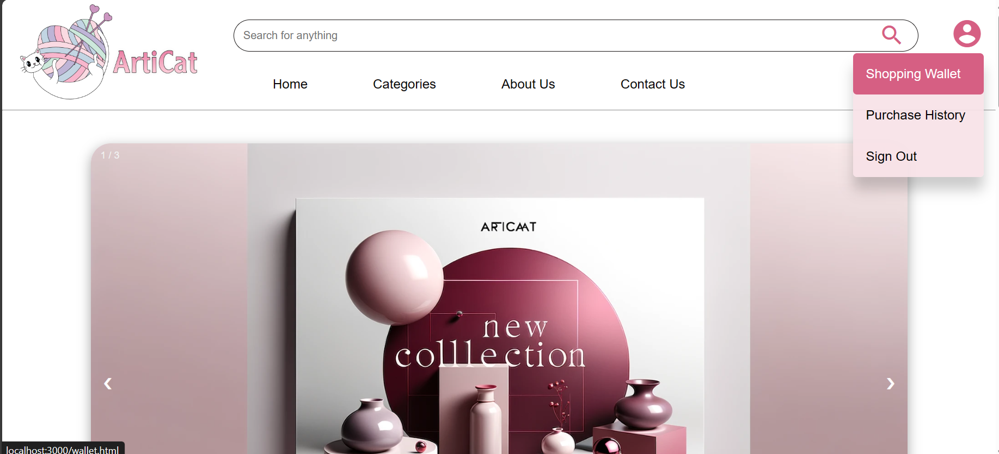

### Seller successfully logs in:

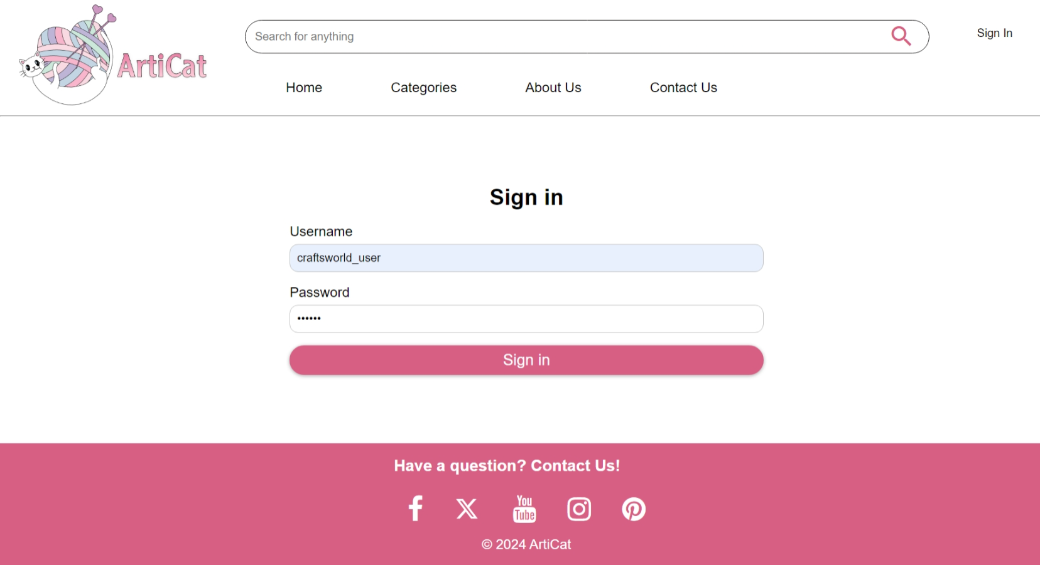

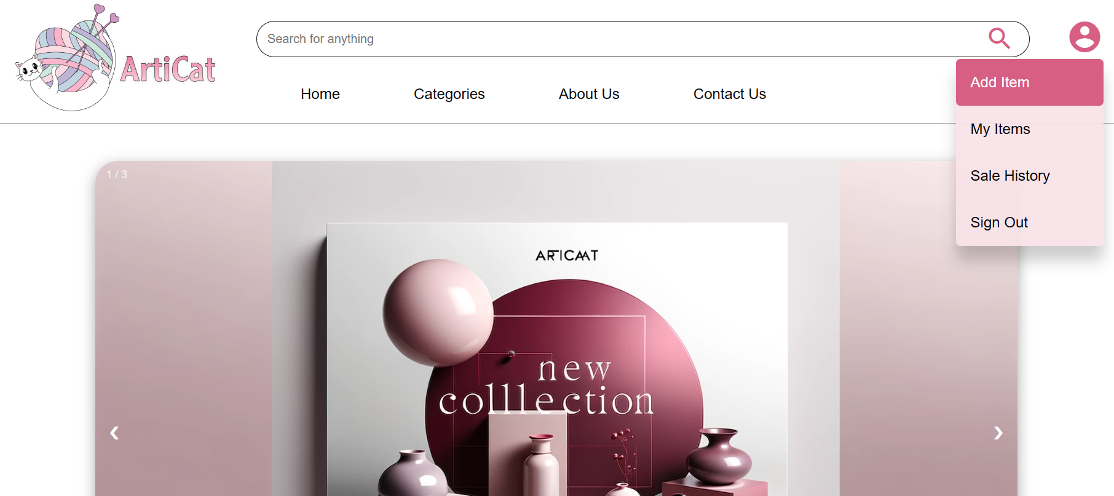

## Usecase 2: Search available items

### No item available:

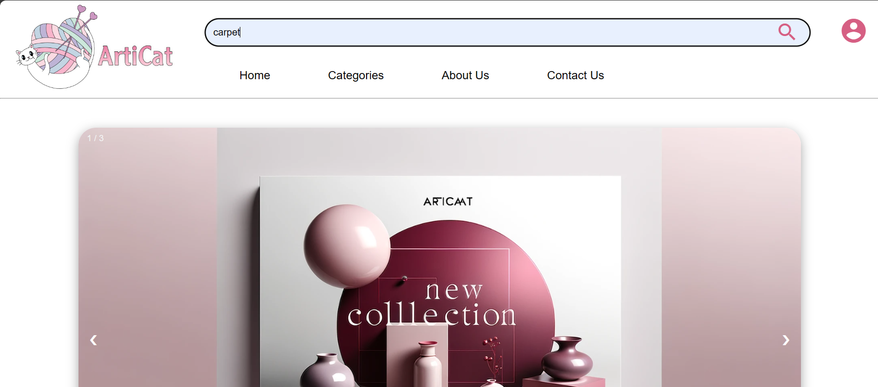

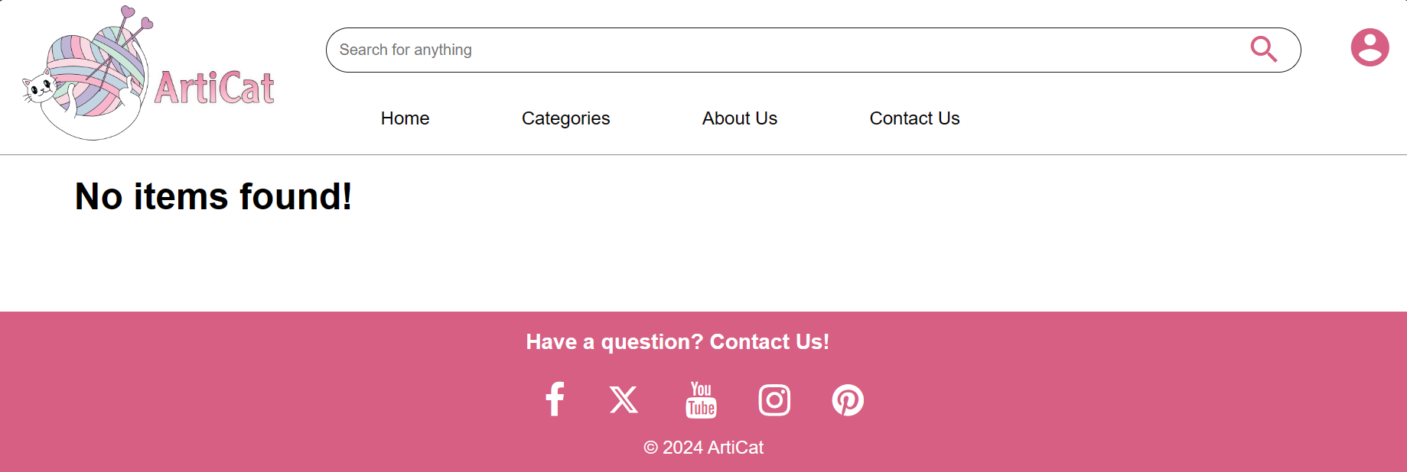

### Some available:



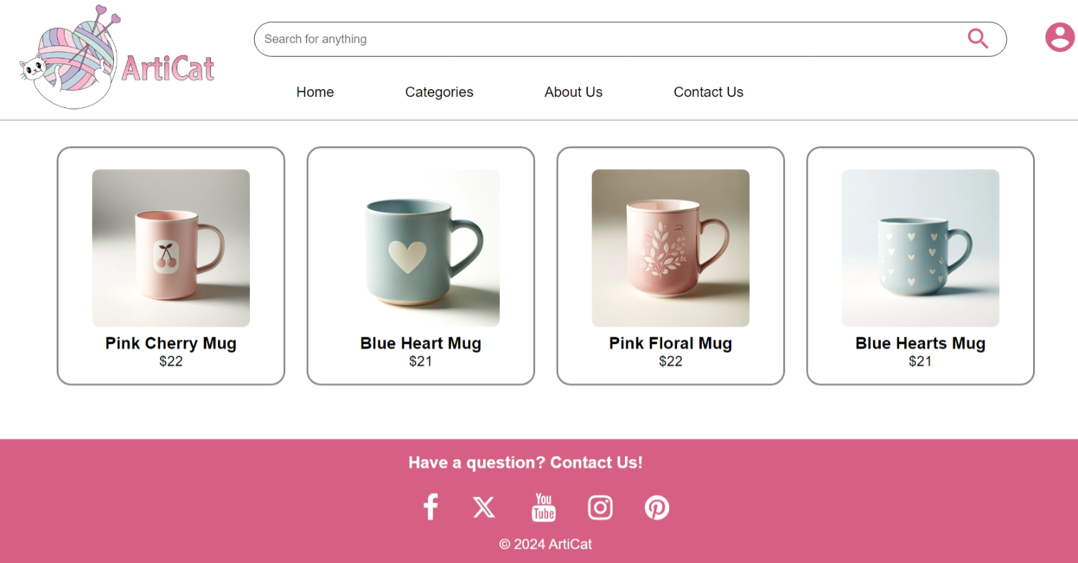

### Another search where some are available:



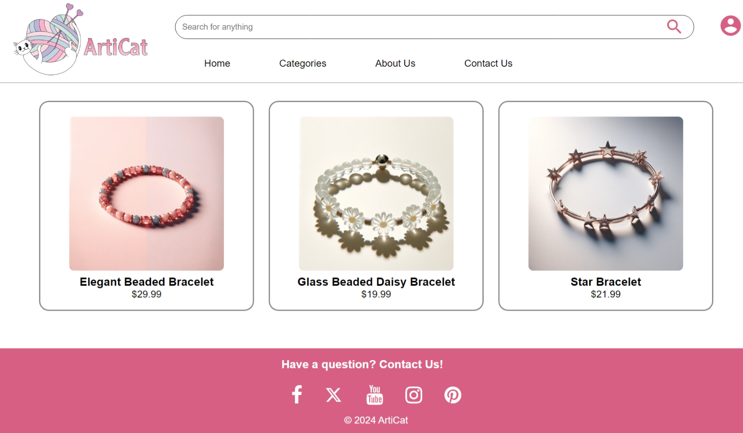

## Usecase 3: Purchase an item

### Purchasing when not logged in (fails):

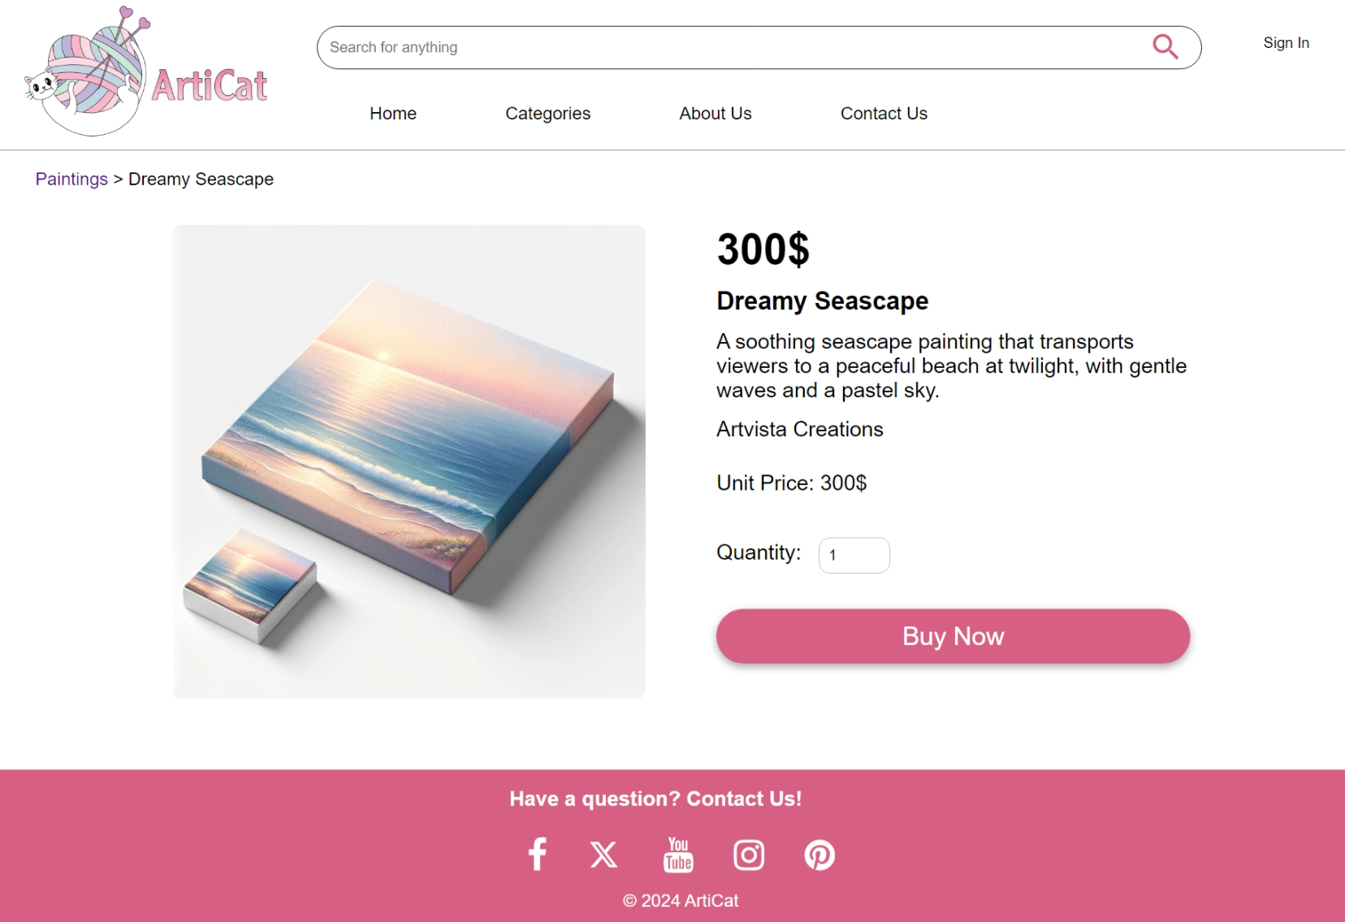

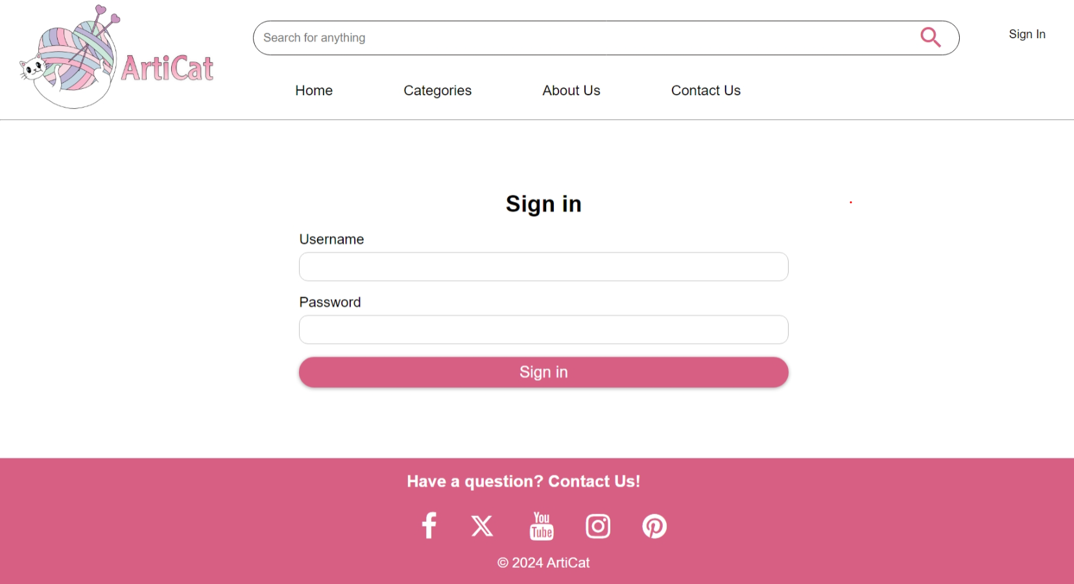

Figure : redirects to sign in page

### Purchasing where customer does not have enough balance:

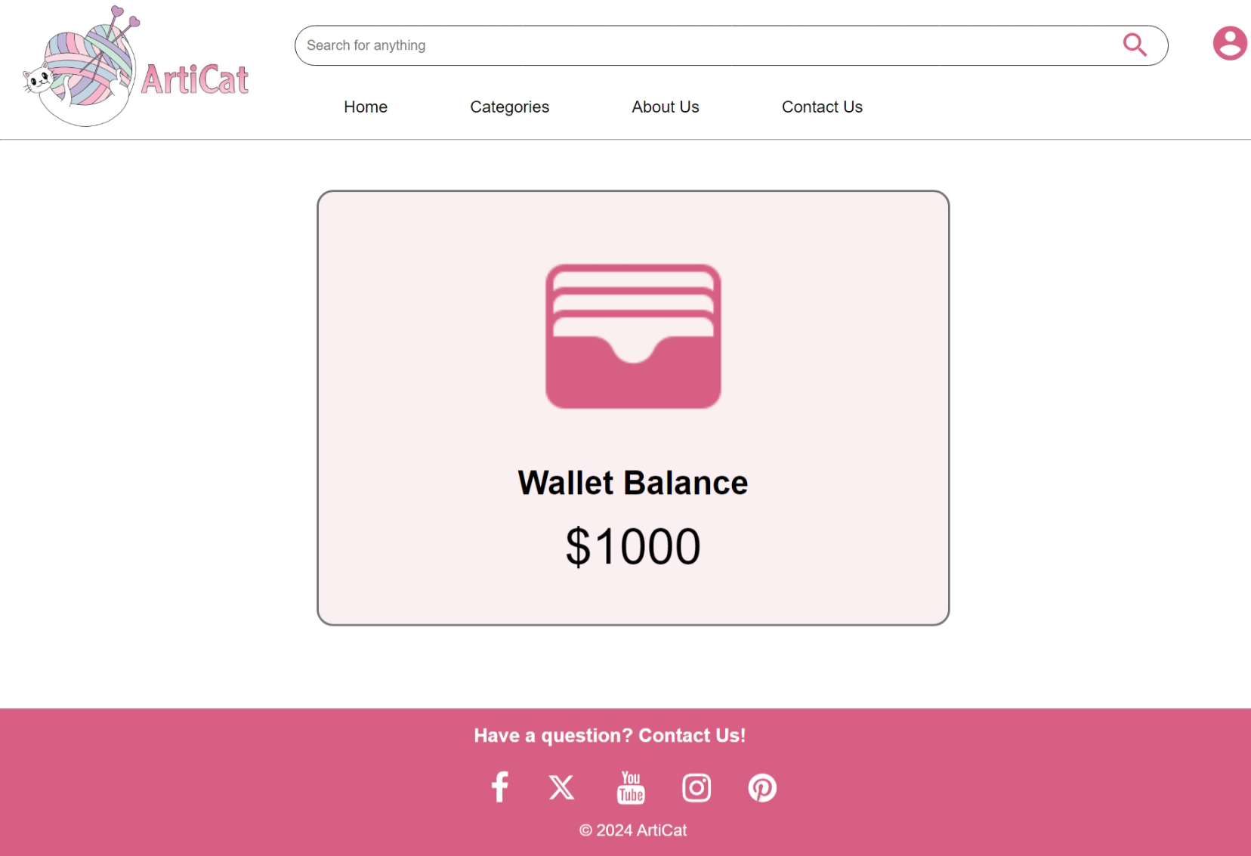

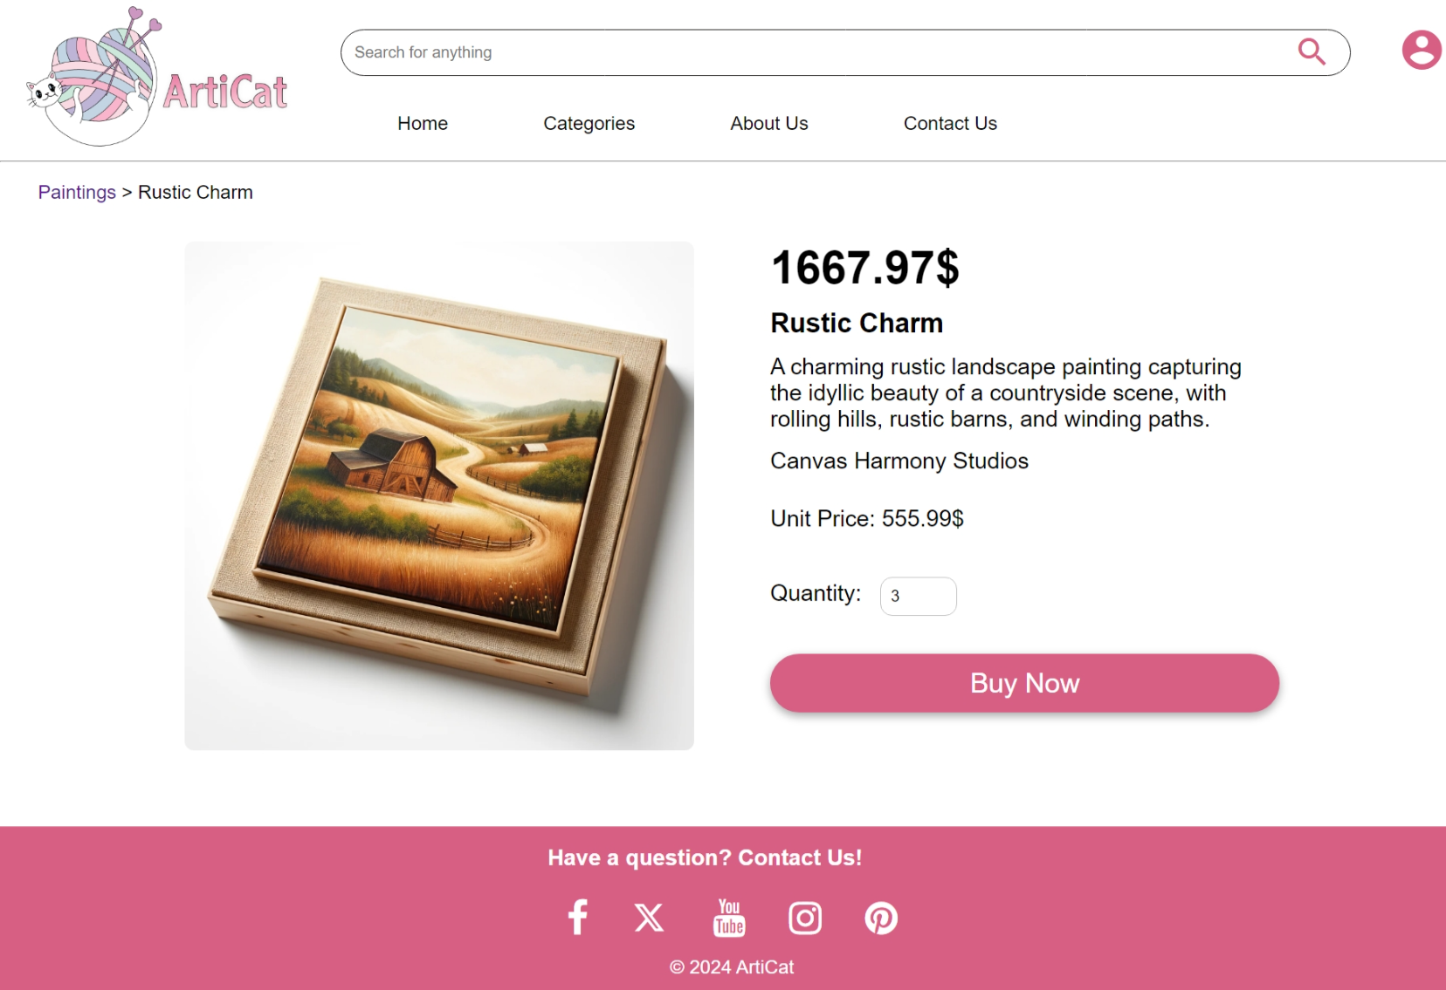

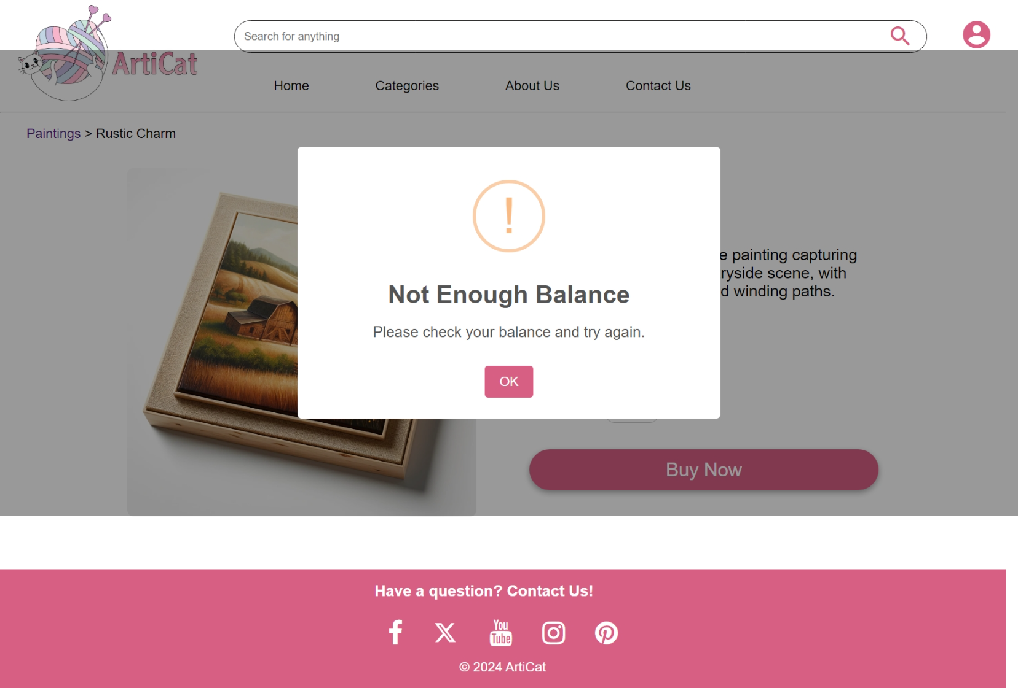

### Purchasing an item successfully:





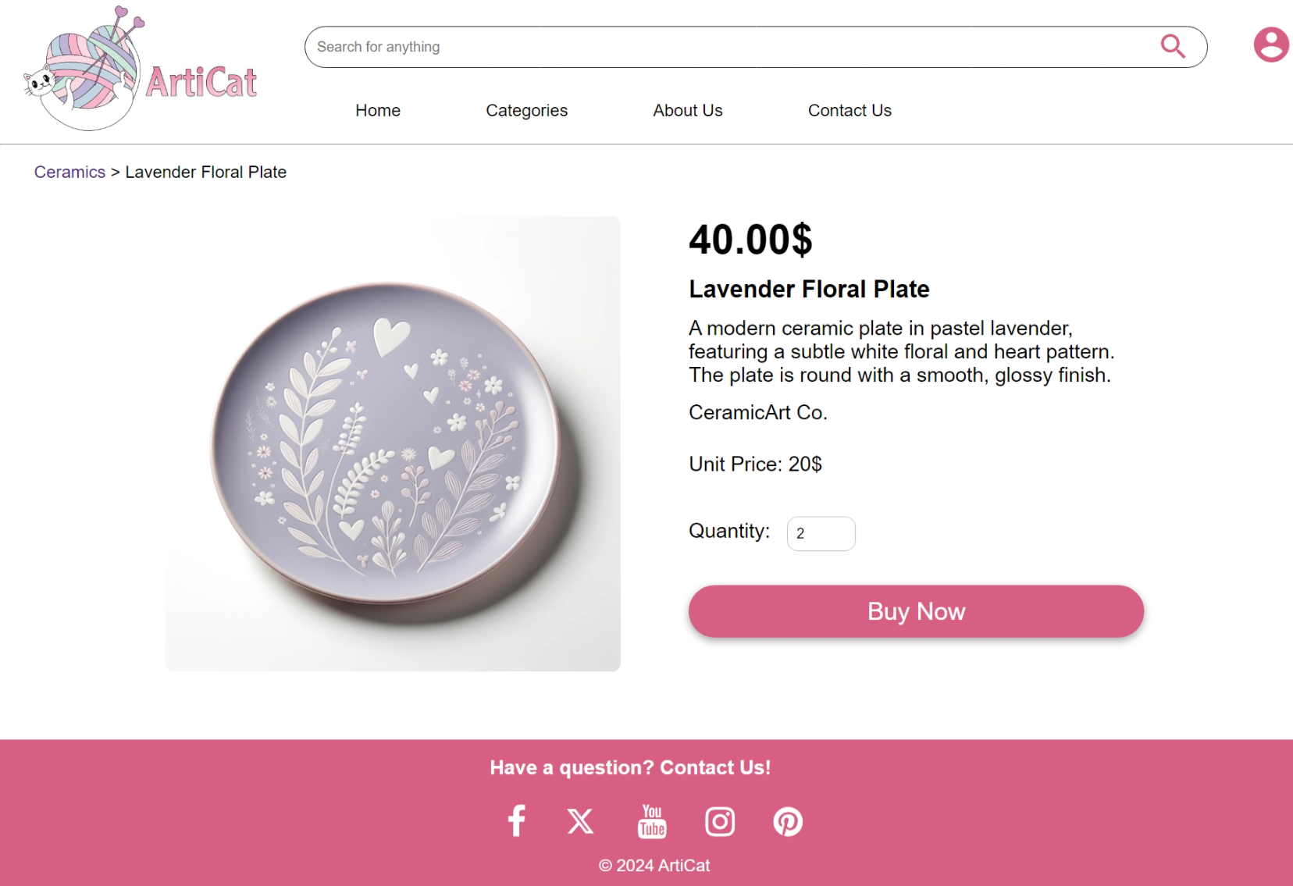

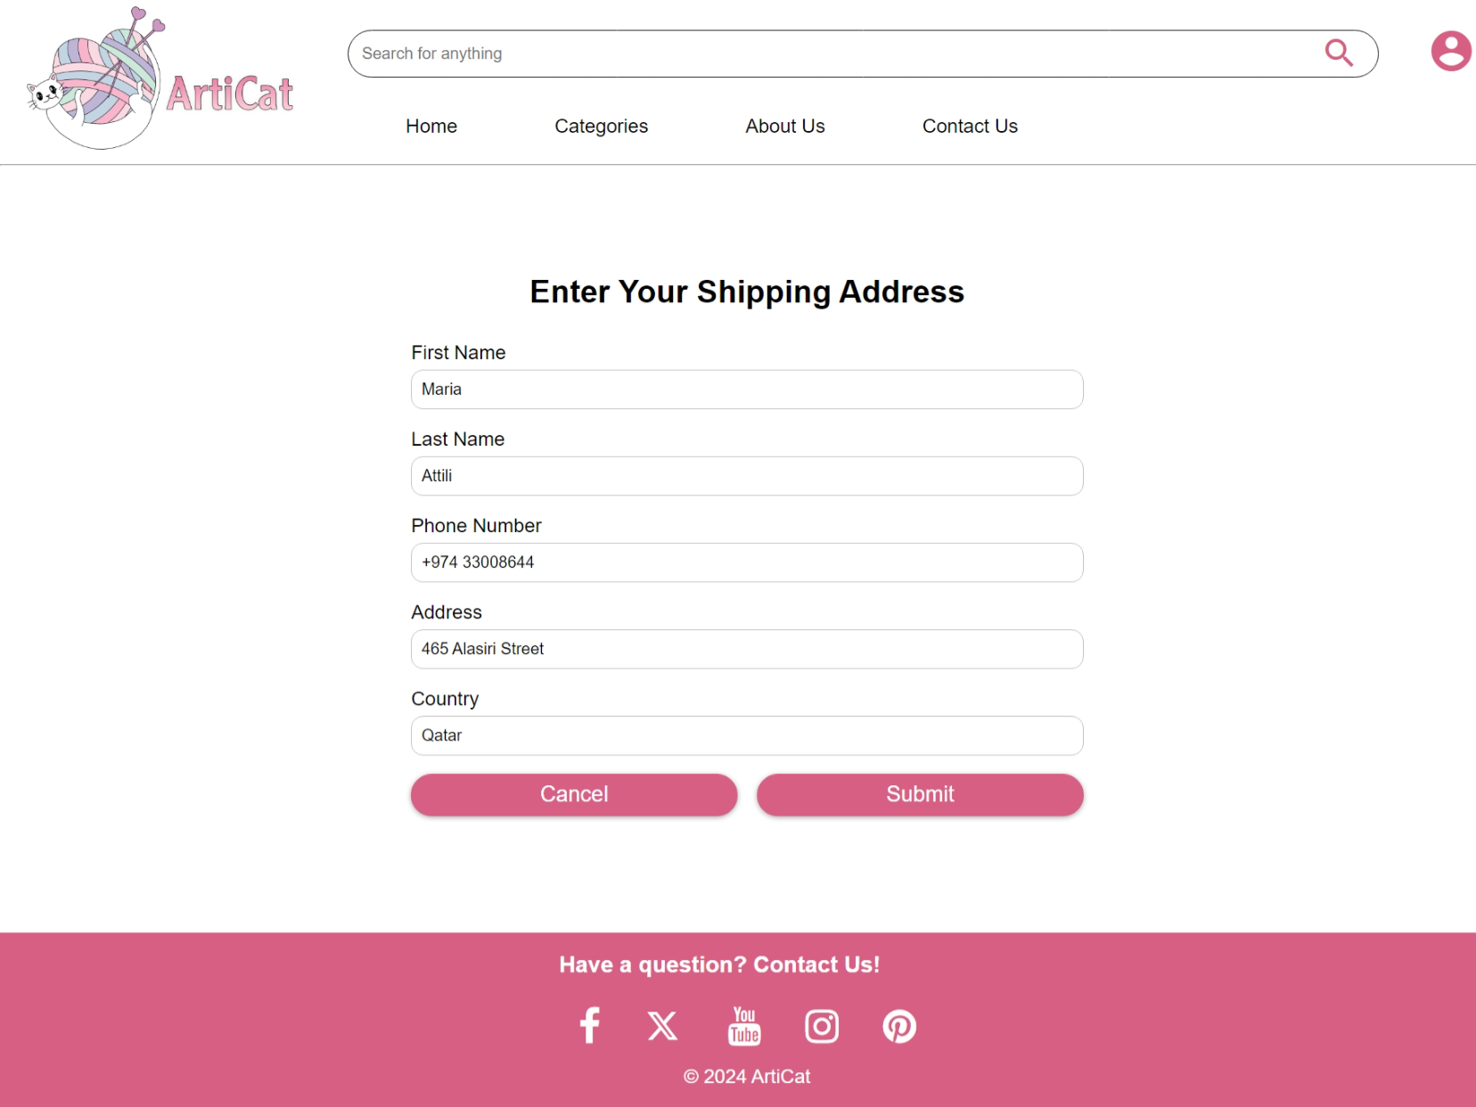

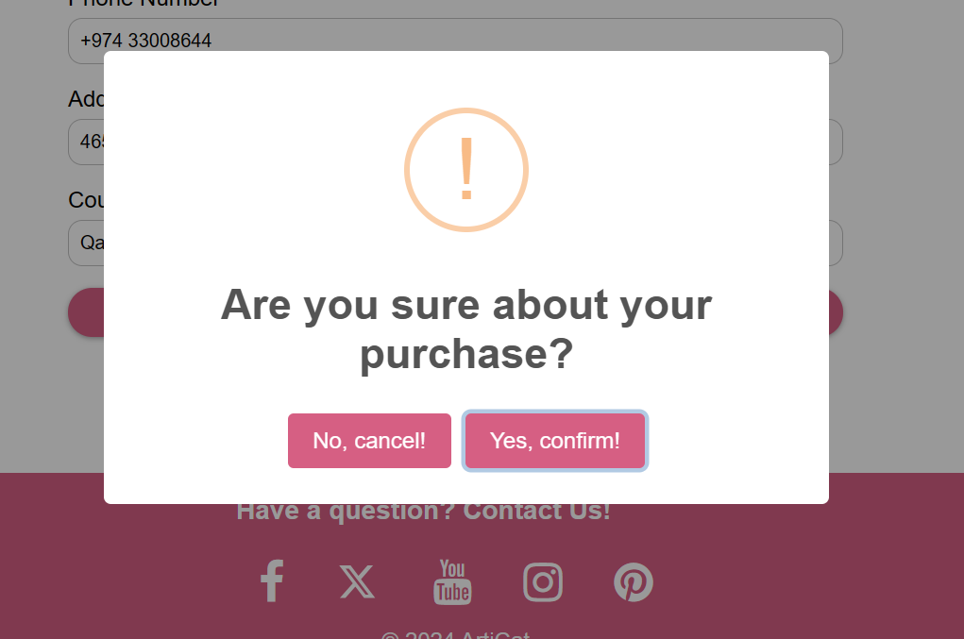

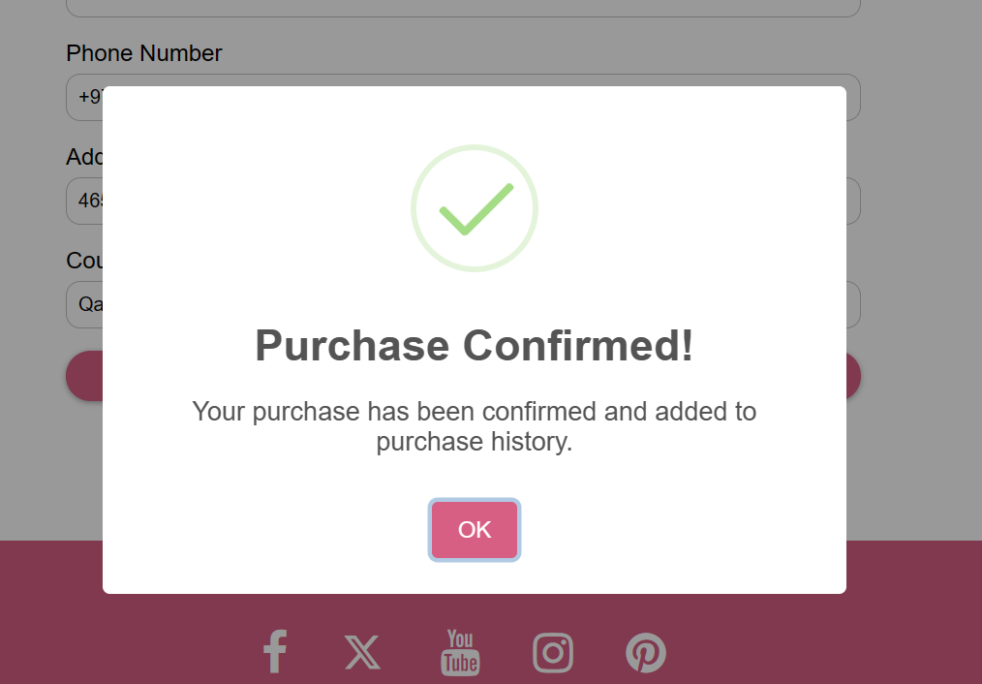







## Usecase 4: View the purchase history

### History shows item has been bought:



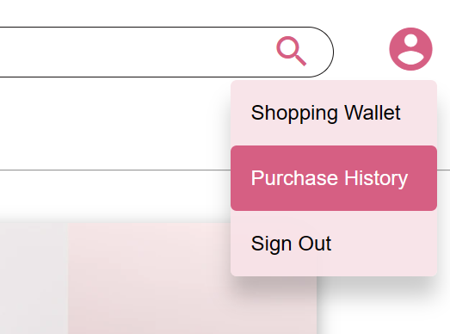

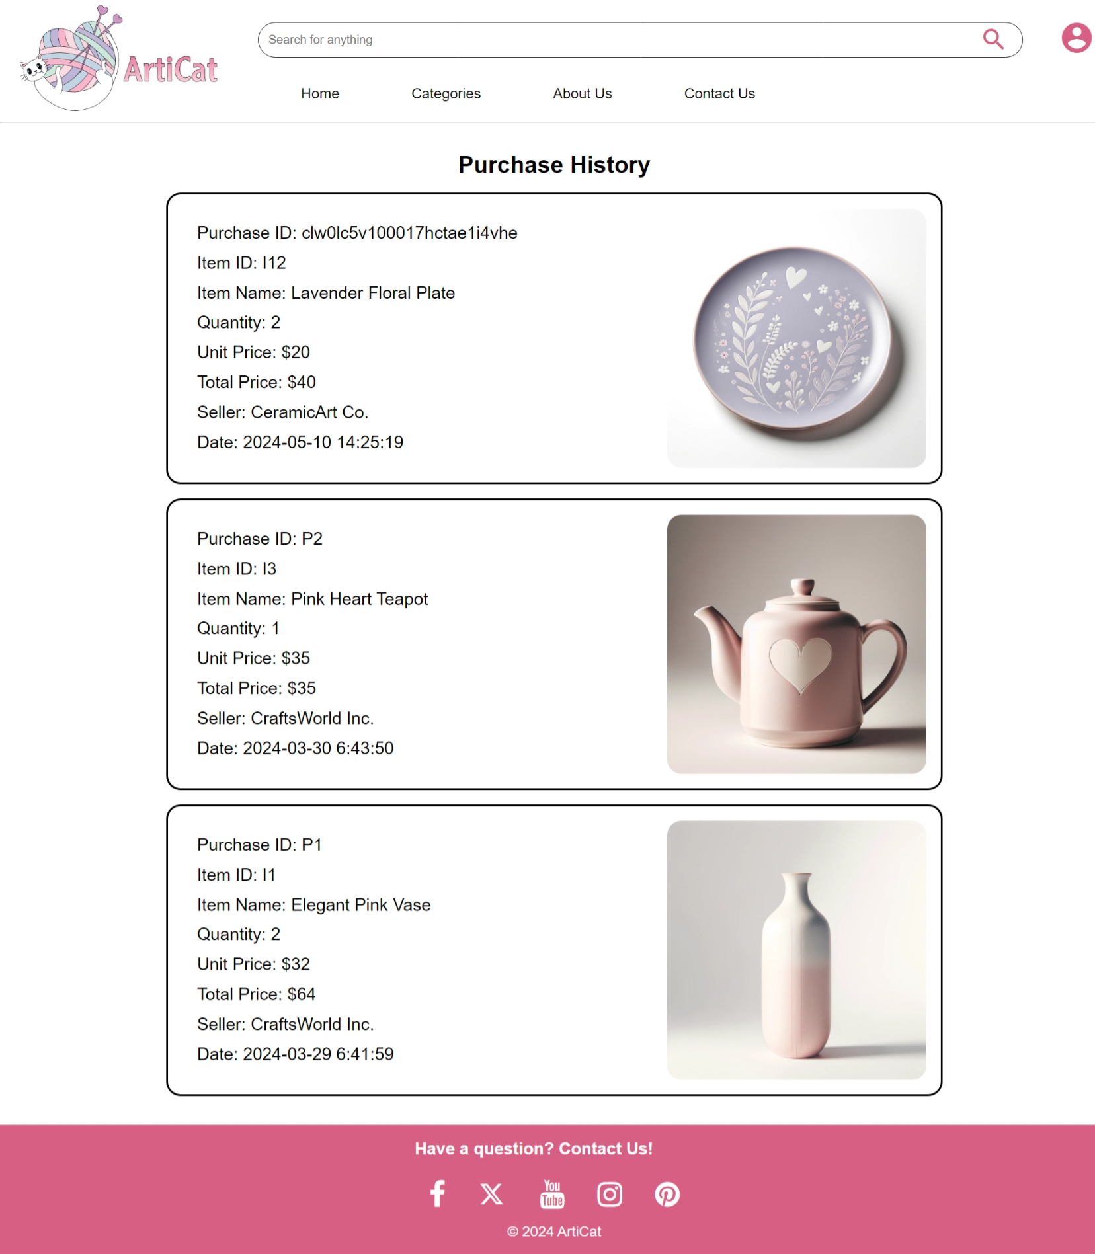

## Usecase 5&6: Upload an item and view available items on sale and sale history

### Upload an item:

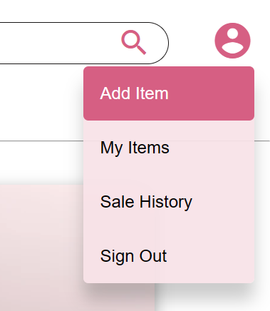

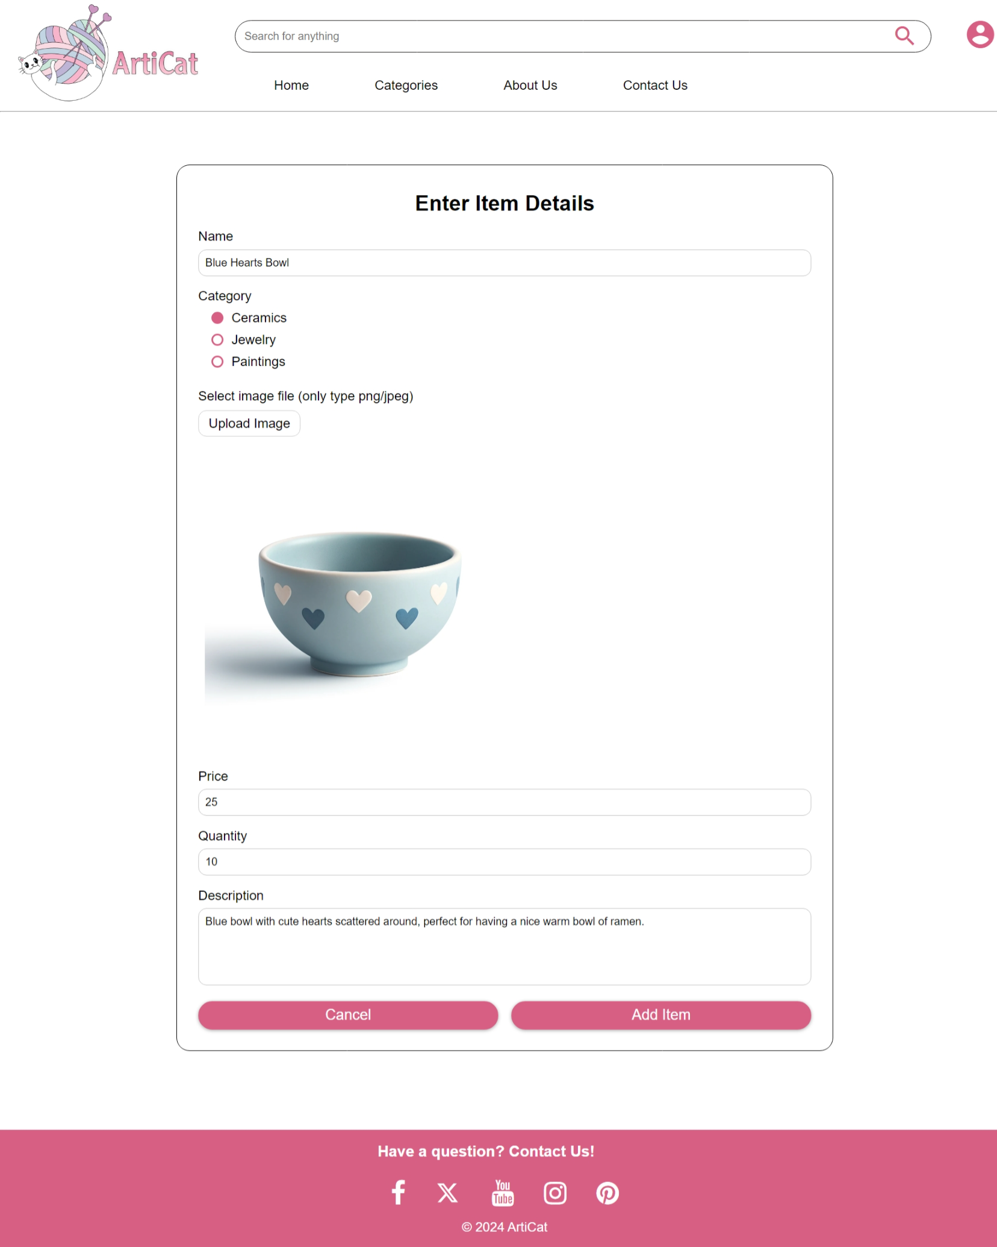

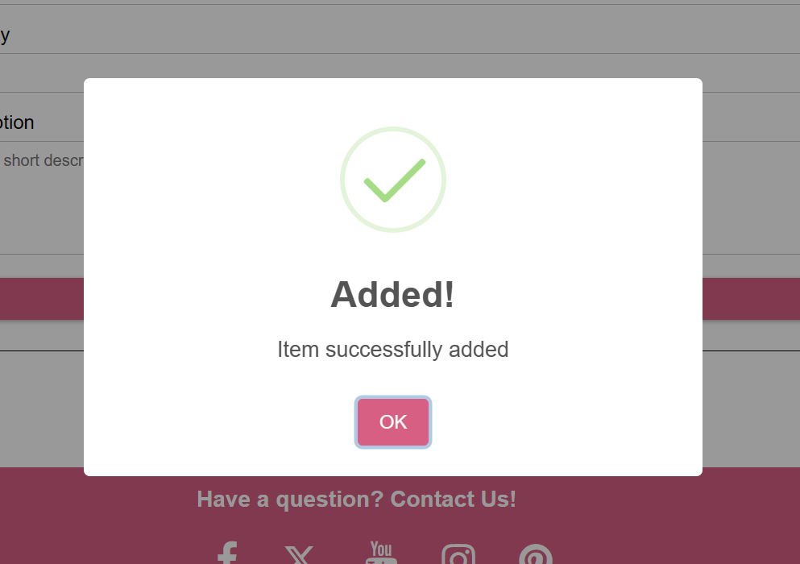

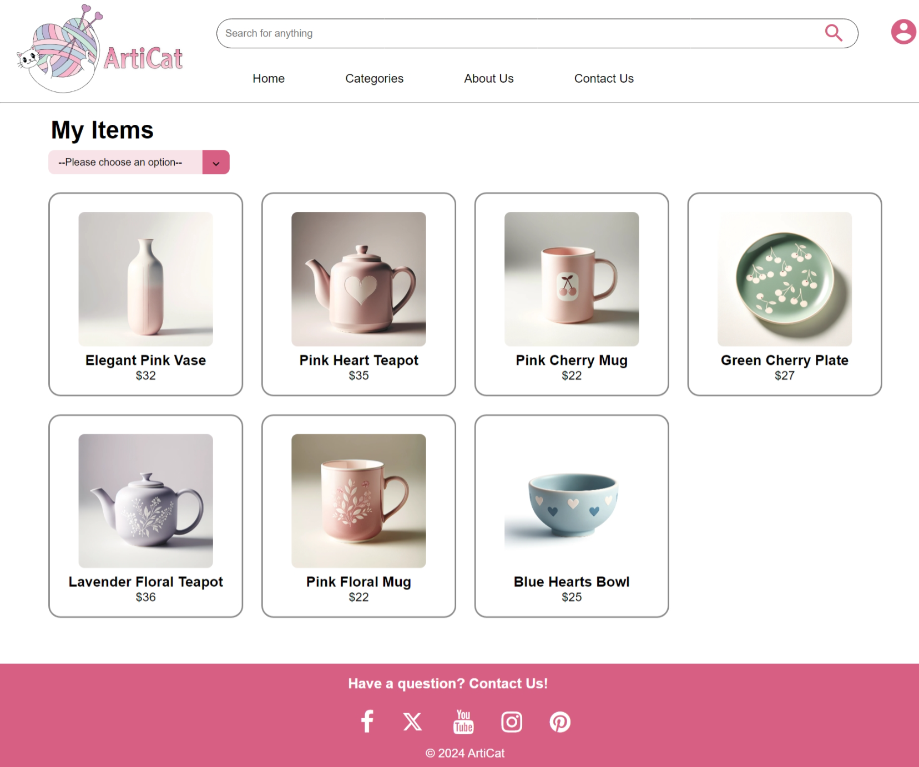



### Uploaded item now searchable:



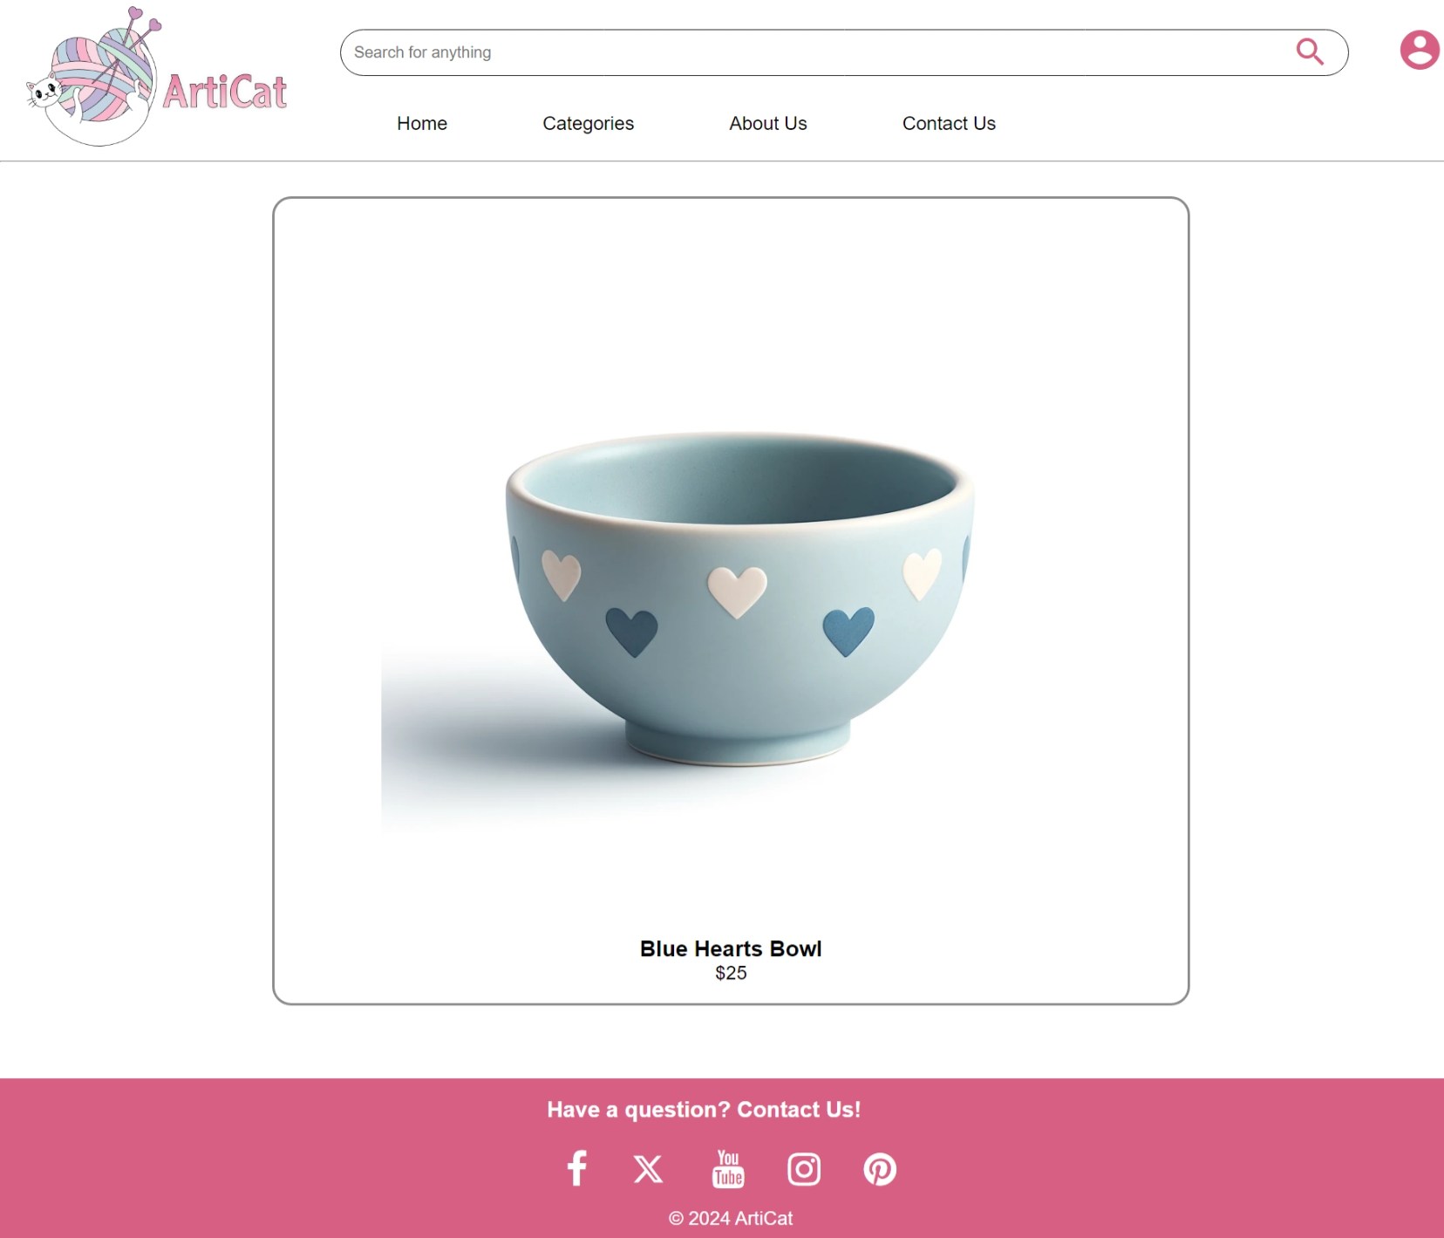

### Uploaded item on available item list:

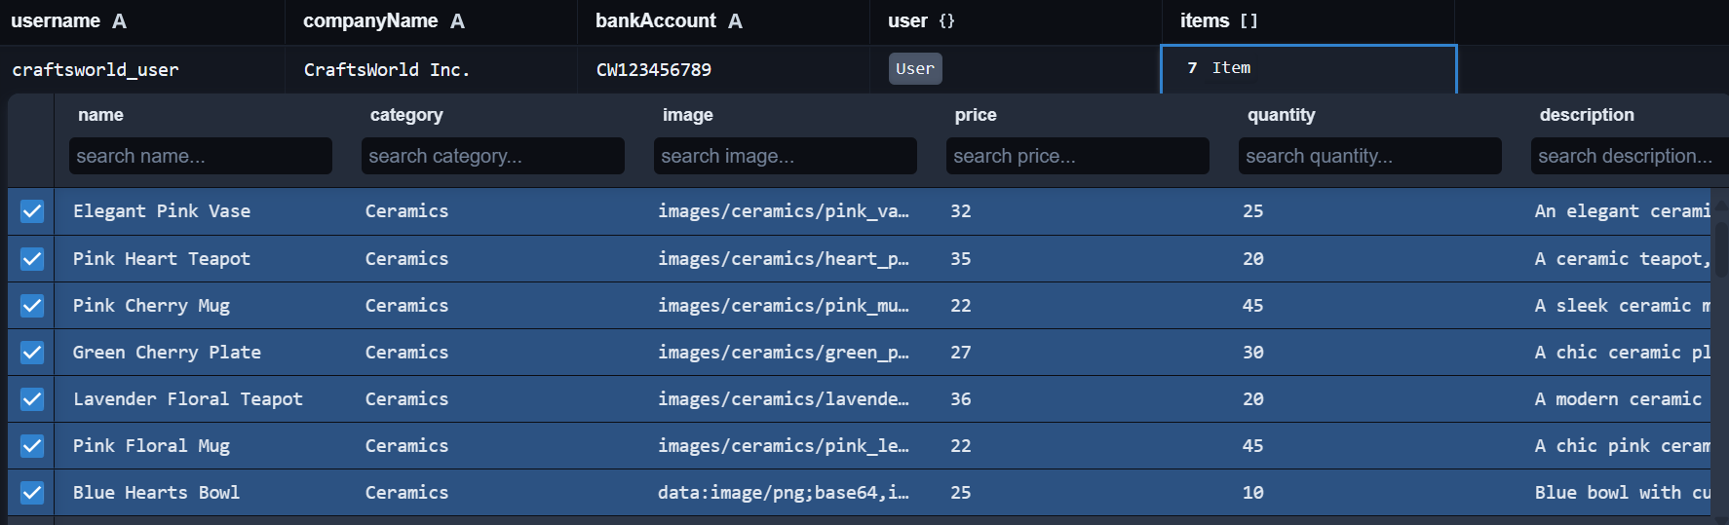



### When an item is sold, quantity decreases:

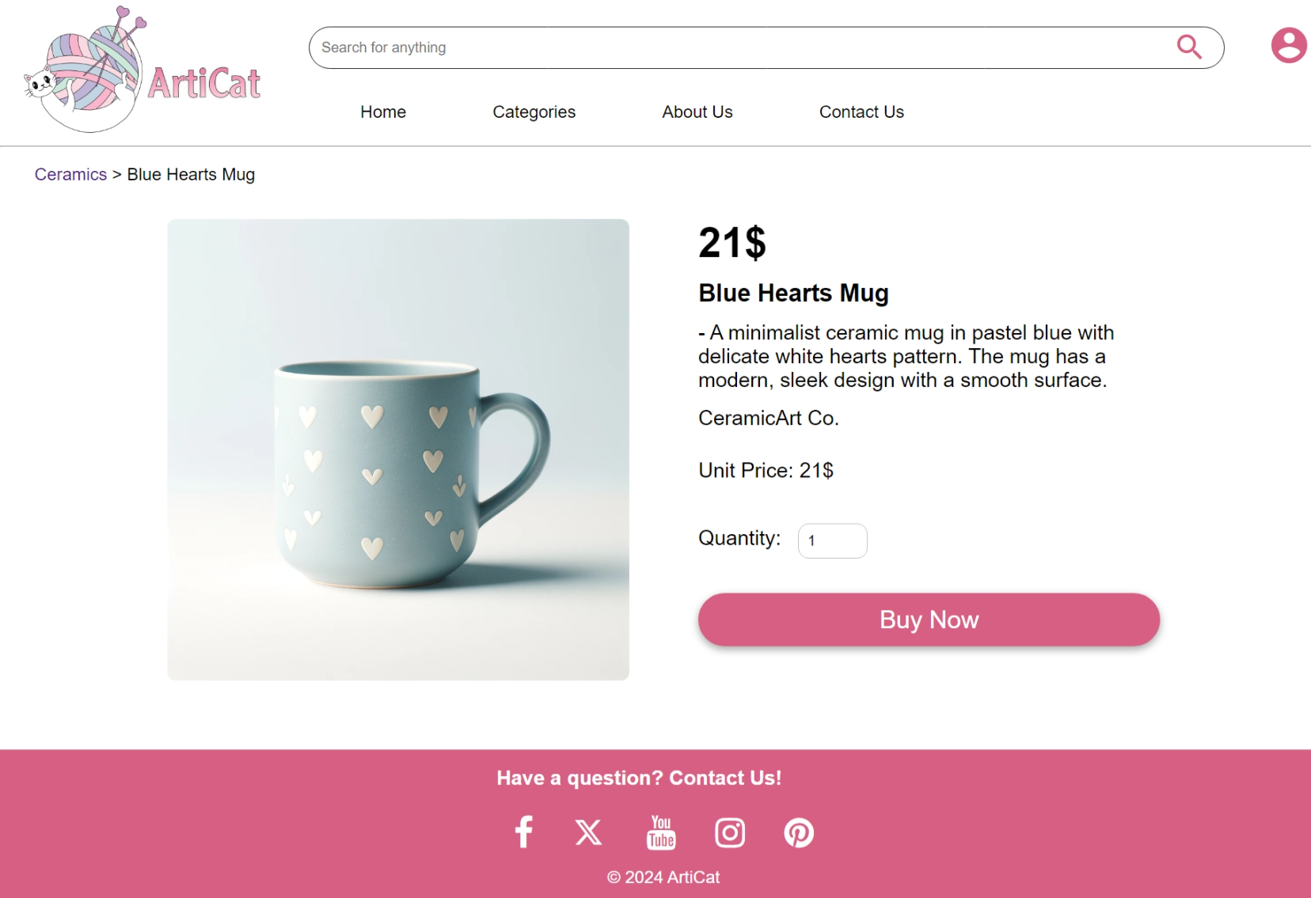

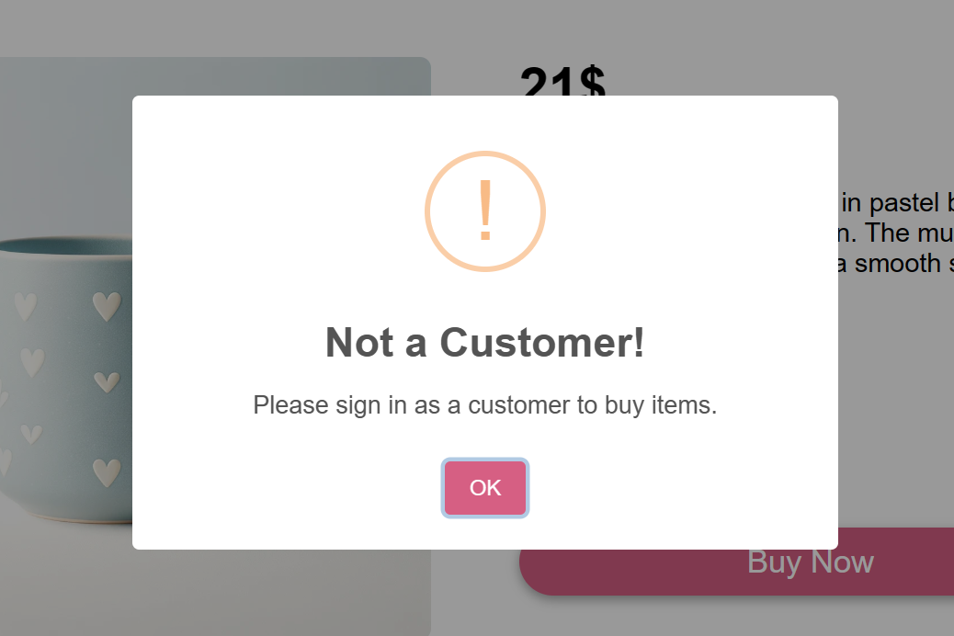

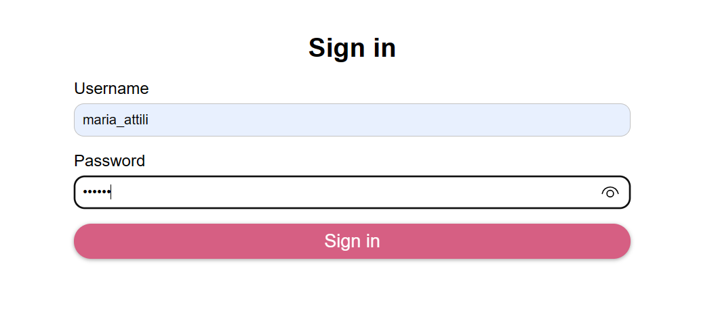

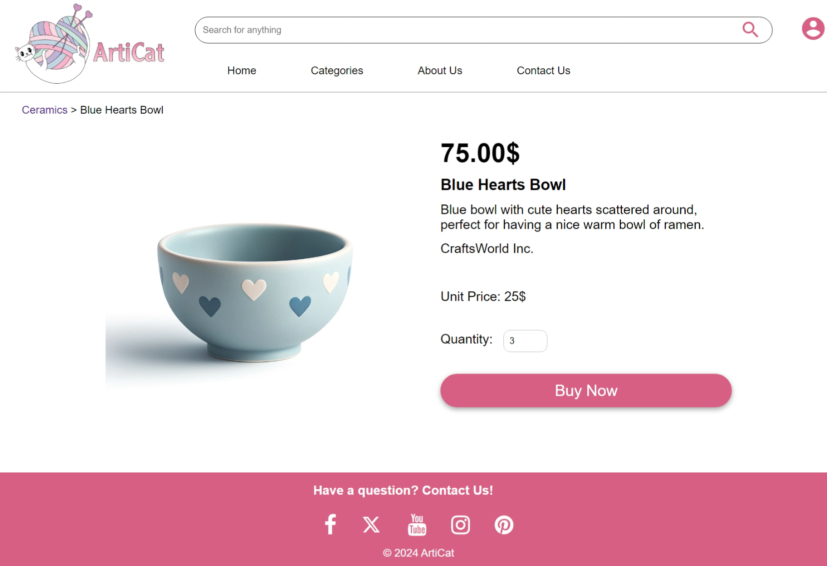

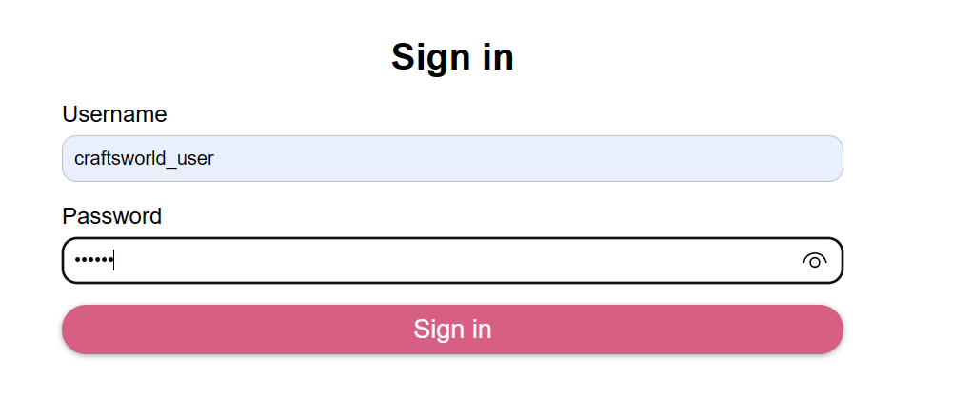

Figure : seller

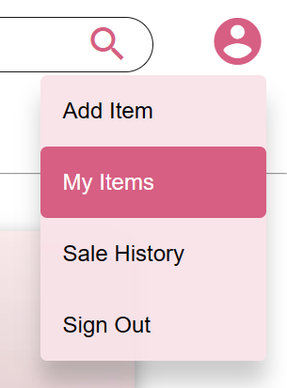

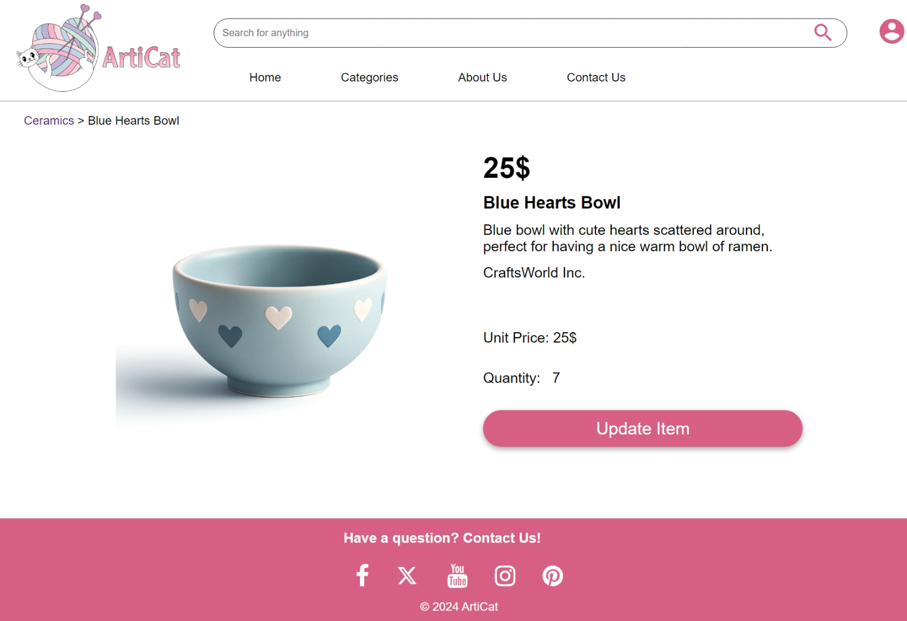



## Usecase 7: Statistics

### Login As Admin:

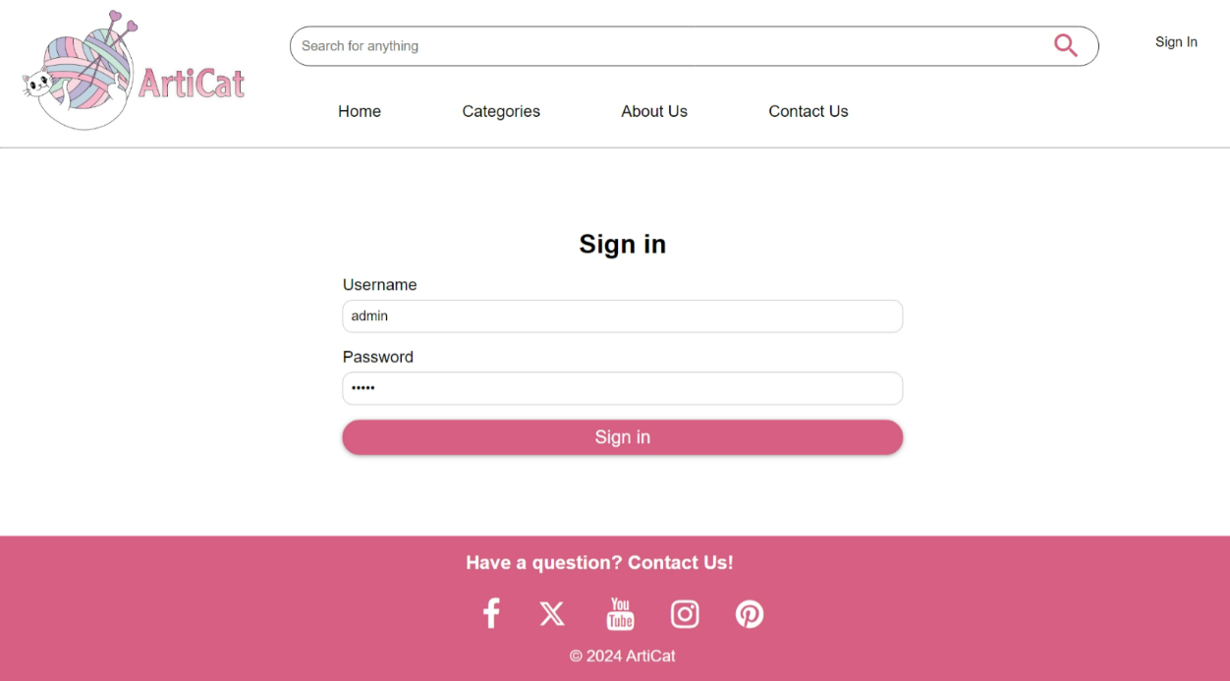

### Statistics Page:

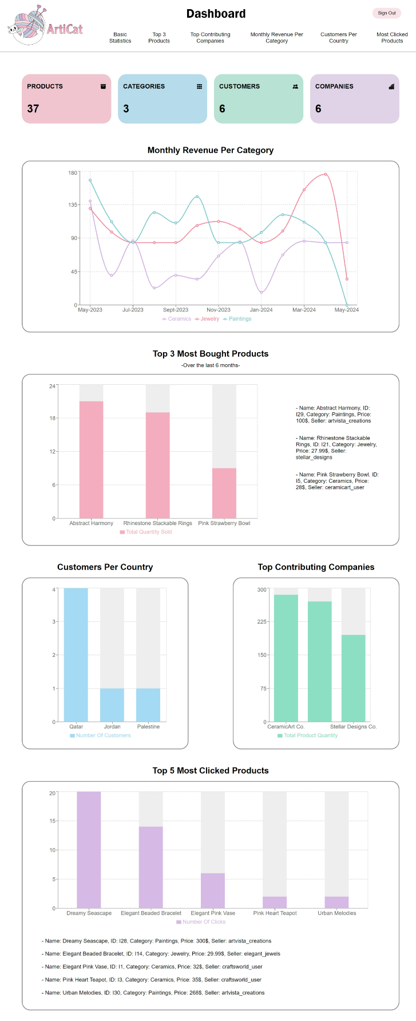

### Changes in Statistics

#### Initial number of products (38):

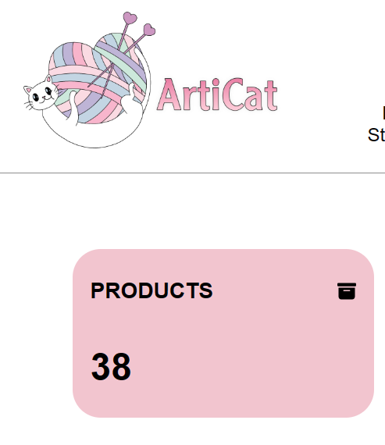

#### Adding an item:

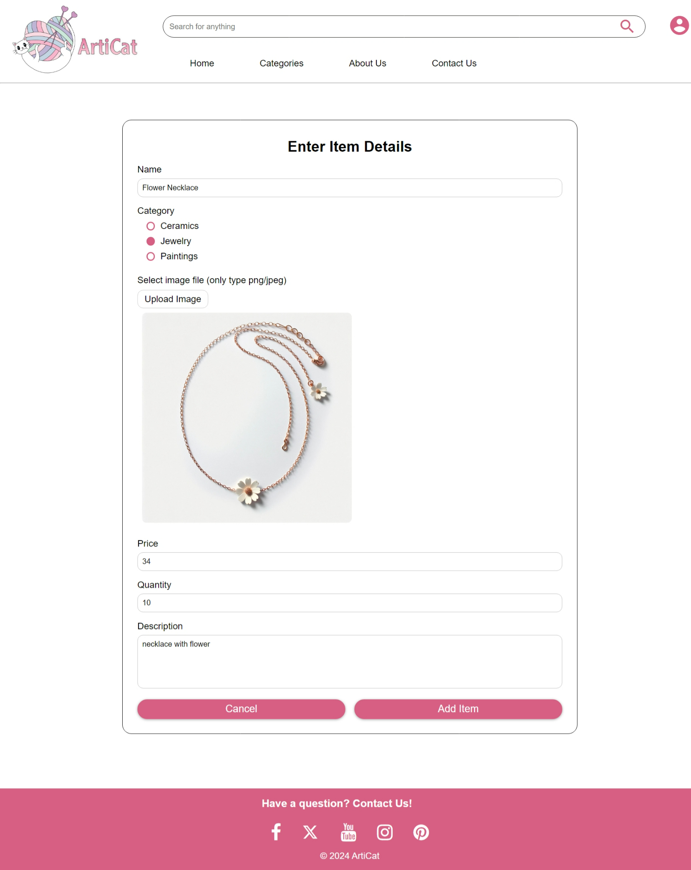

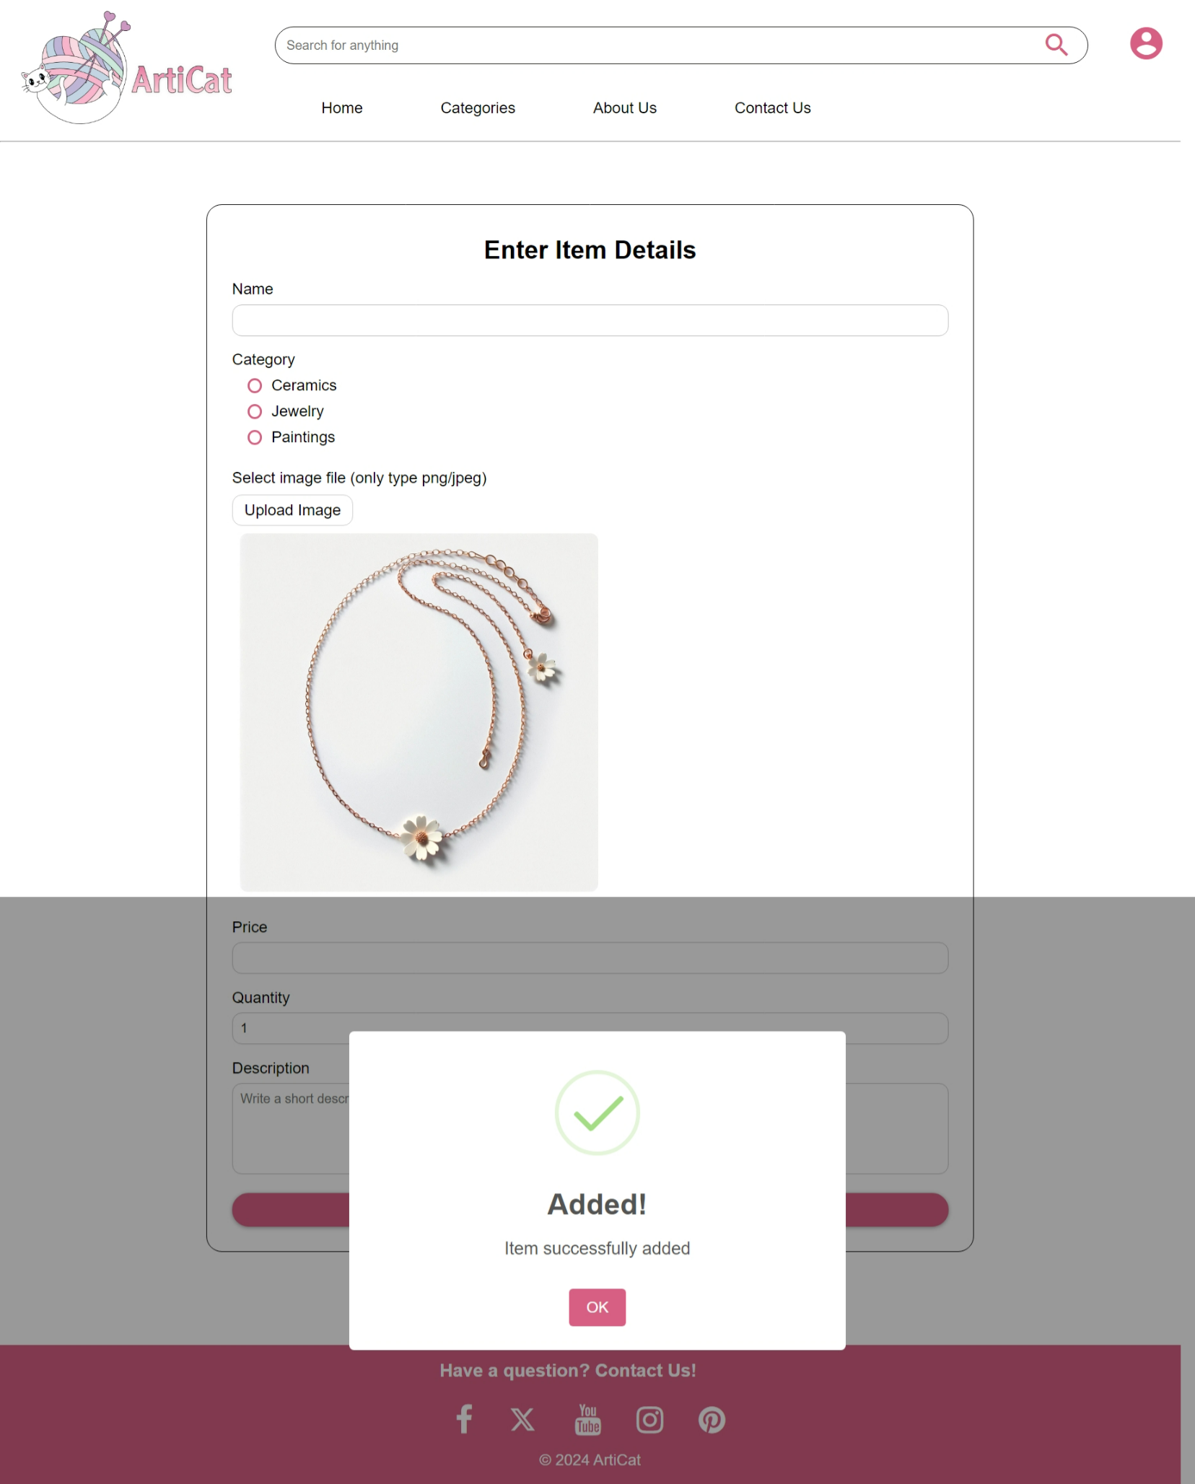

#### New no. of products (39):

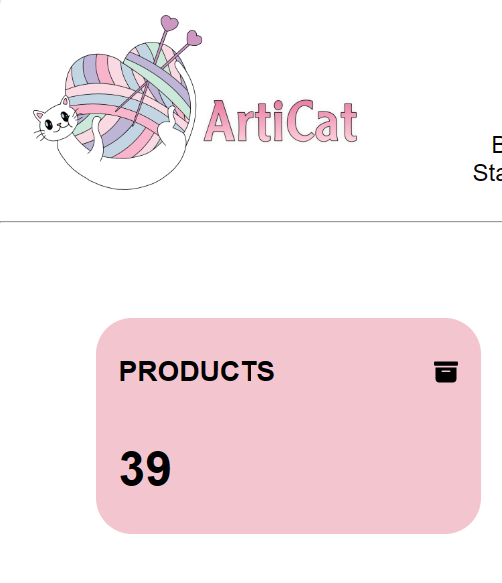

# Deploying website using Vercel

We attempted to deploy our website using Vercel. We were successful in the deployment. Unfortunately, only the statistics page which makes use of NextJs and React completely is fully functional with the data from the database.

We noticed that Vercel is not compatible with SQLite which is the database that we used. <https://vercel.com/guides/is-sqlite-supported-in-vercel> This is the reason the API routes did not work as the database file is stored as a temporary file in the server.

Deployed Website Link: <https://articat.vercel.app/>

Statistics Page: <https://articat.vercel.app/statistics>

# References:

<https://recharts.org/en-US/>

<https://react-icons.github.io/react-icons/search/#q=organi>